Public

📌 Definition:
# Source: AI Source: Provided by: [Data Path: Persons Table -> ID Column: 1, Name_En Column: Motasem Essam] -> From: [Chatgpt (GPT‑5 Mini)] on [12/9/2025]
Public is an access modifier that allows a variable or method to be accessed from anywhere in the program, without any restrictions.

🧠 Simple idea:
# Source: AI Source: Provided by: [Data Path: Persons Table -> ID Column: 1, Name_En Column: Motasem Essam] -> From: [Chatgpt (GPT‑5 Mini)] on [12/9/2025]
Public = “Accessible from everywhere” 🌐

🔍 Key characteristics:
# Source: AI Source: Provided by: [Data Path: Persons Table -> ID Column: 1, Name_En Column: Motasem Essam] -> From: [Chatgpt (GPT‑5 Mini)] on [12/9/2025]
- 🌍 Accessible from any class, any package
- 🔗 No restrictions on access
- 🧩 Often used for methods that should be widely available
- ⚙️ Represents the least restrictive access level

📌 Example (Java):
# Source: AI Source: Provided by: [Data Path: Persons Table -> ID Column: 1, Name_En Column: Motasem Essam] -> From: [Chatgpt (GPT‑5 Mini)] on [12/9/2025]
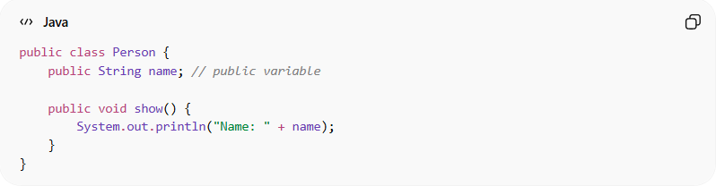
public class Person {
public String name; // public variable

public void show() {
System.out.println("Name: " + name);
}
}

Usage from another class:
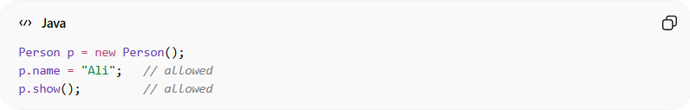
Person p = new Person();
p.name = "Ali"; // allowed
p.show(); // allowed

🔄 Access summary:
# Source: AI Source: Provided by: [Data Path: Persons Table -> ID Column: 1, Name_En Column: Motasem Essam] -> From: [Chatgpt (GPT‑5 Mini)] on [12/9/2025]
Access Level | Same Class | Same Package | Subclass | Other Packages
Public | ✔️ | ✔️ | ✔️ | ✔️

🎯 Why public is important:
# Source: AI Source: Provided by: [Data Path: Persons Table -> ID Column: 1, Name_En Column: Motasem Essam] -> From: [Chatgpt (GPT‑5 Mini)] on [12/9/2025]
- 🌍 Provides global access to functionality
- 🔄 Enables interaction between different parts of a system
- 🧩 Useful for APIs and reusable libraries
- ⚙️ Makes methods and classes accessible for use

⚠️ Note:
# Source: AI Source: Provided by: [Data Path: Persons Table -> ID Column: 1, Name_En Column: Motasem Essam] -> From: [Chatgpt (GPT‑5 Mini)] on [12/9/2025]
- Overusing public can break encapsulation
- Sensitive data should usually be kept private

🎯 Summary:
# Source: AI Source: Provided by: [Data Path: Persons Table -> ID Column: 1, Name_En Column: Motasem Essam] -> From: [Chatgpt (GPT‑5 Mini)] on [12/9/2025]
Public access allows members to be accessed from anywhere in the program, making them fully visible and widely usable.

